JAVA ASSIGNMENT

AIM:
Development of Kongu Engineering College (R2024) Student Academic & Continuous Evaluation System using Java JDBC.

OBJECTIVE:
Design and develop a database-driven Java application using JDBC to manage student records, perform incremental marks entry (Continuous Internal Assessments and End Semester Examinations), enforce attendance eligibility rules, and generate formal academic performance reports according to
Kongu Engineering College (Autonomous) - Regulation 2024.
System Requirements & Specifications.

MAIN MENU:
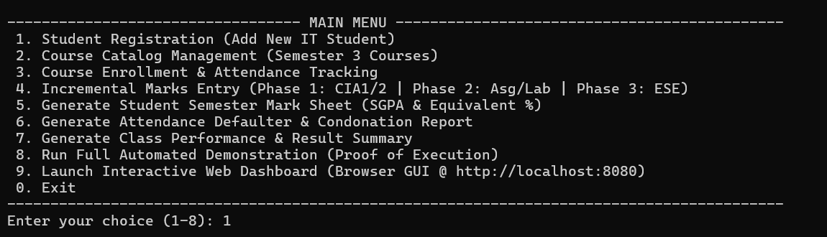

STUDENT & COURSE MANAGEMENT:

1.STUDENT REGISTRATION:
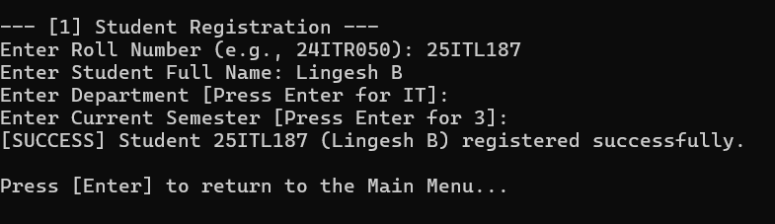
2. COURSE CATALOG:
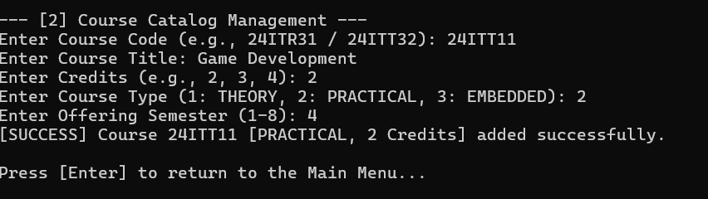
3. COURSE ENROLLMENT & ATTENDANCE TRACKING:
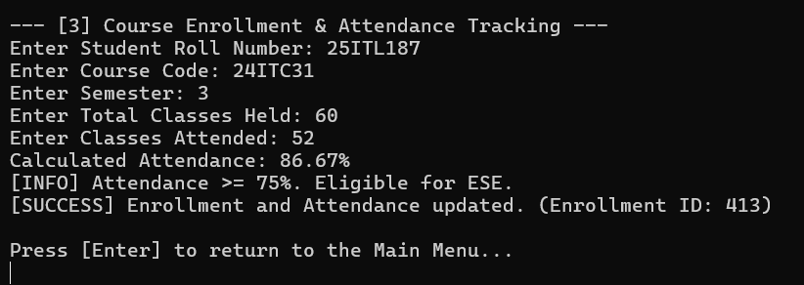

INCREMENTAL MARKS ENTRY:

1.PHASE 1 (MID-SEMESTER):
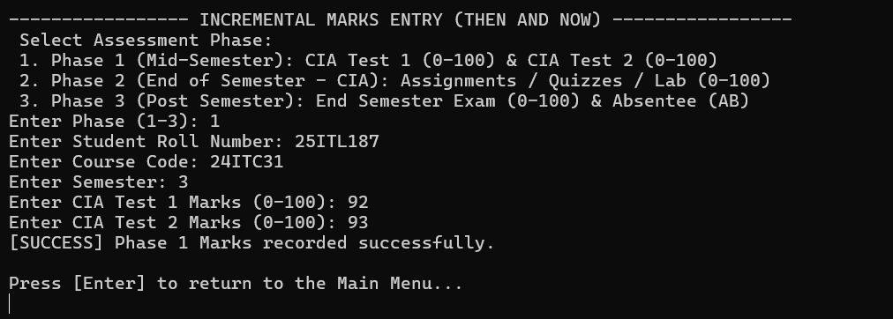
2.PHASE 2 (END OF SEMESTER - CIA):
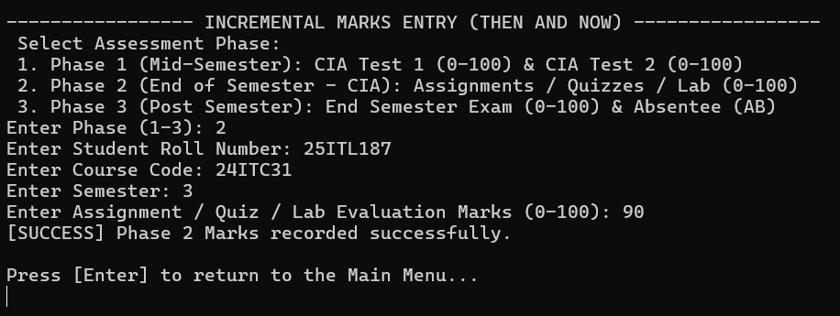
3. PHASE 3 (POST SEMESTER):
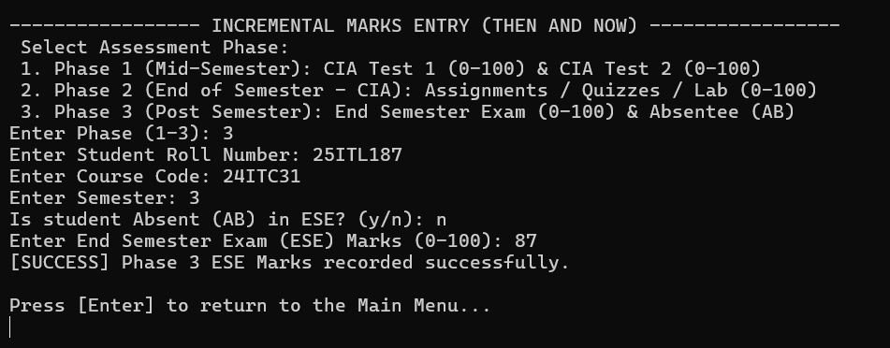
ATTENDANCE & GRADING RULES:

1.ATTENDANCE FILTER:
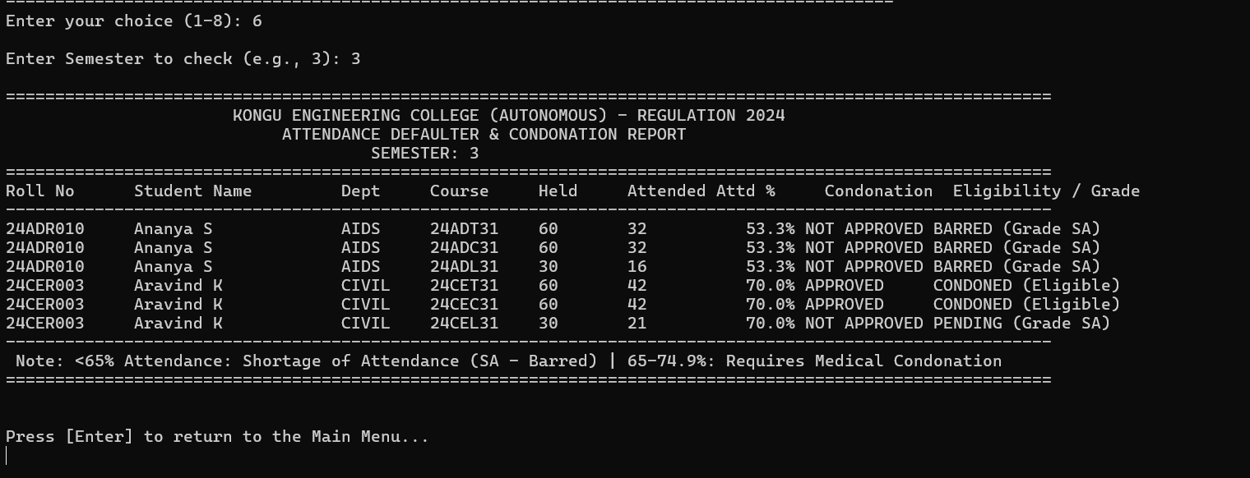

STUDENT SEMESTER MARK SHEET:
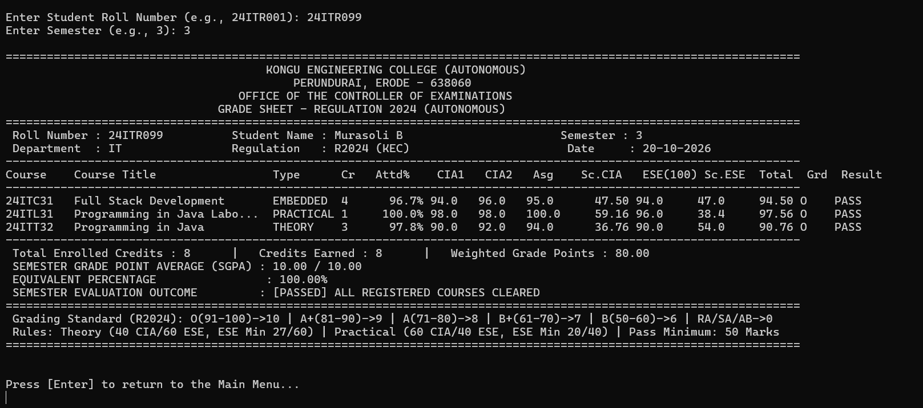

DEPARTMENT WISE CLASS PERFORMANCE & RESULT SUMMARY:

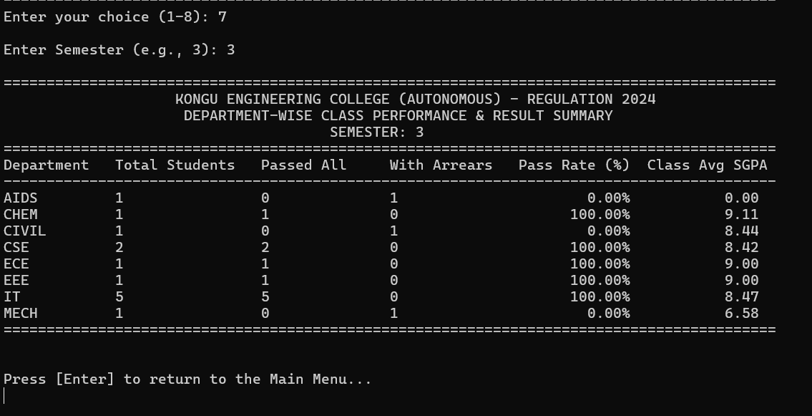

DATABASE:
STUDENTS DATABASE:
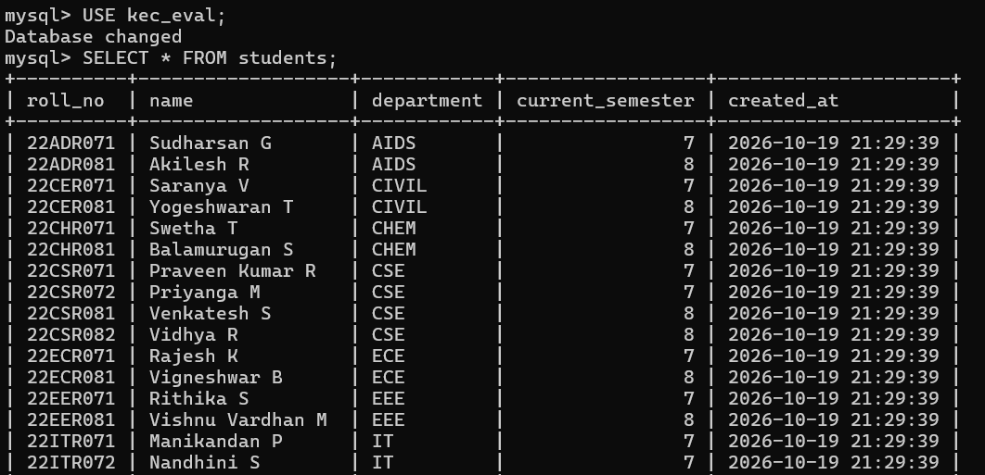

COURSES DATABASE:
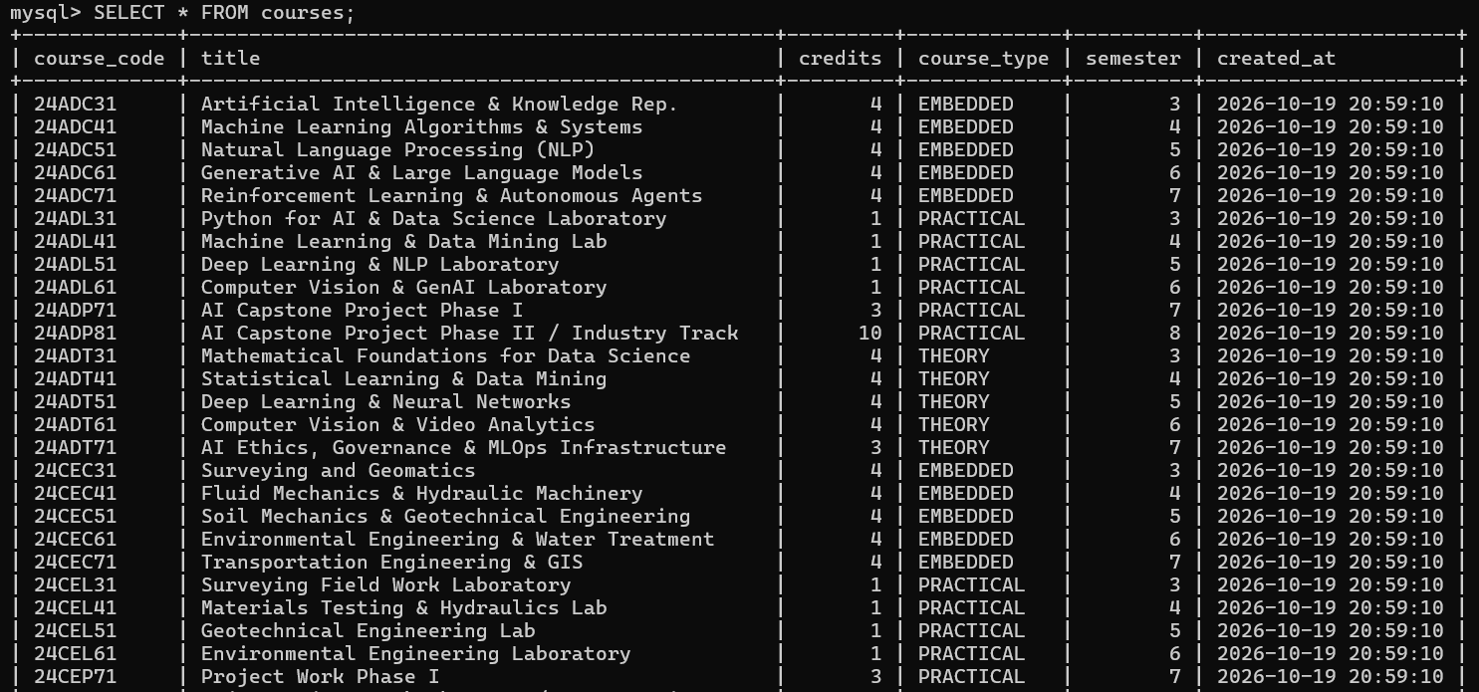
ENROLLMENTS DATABASE:
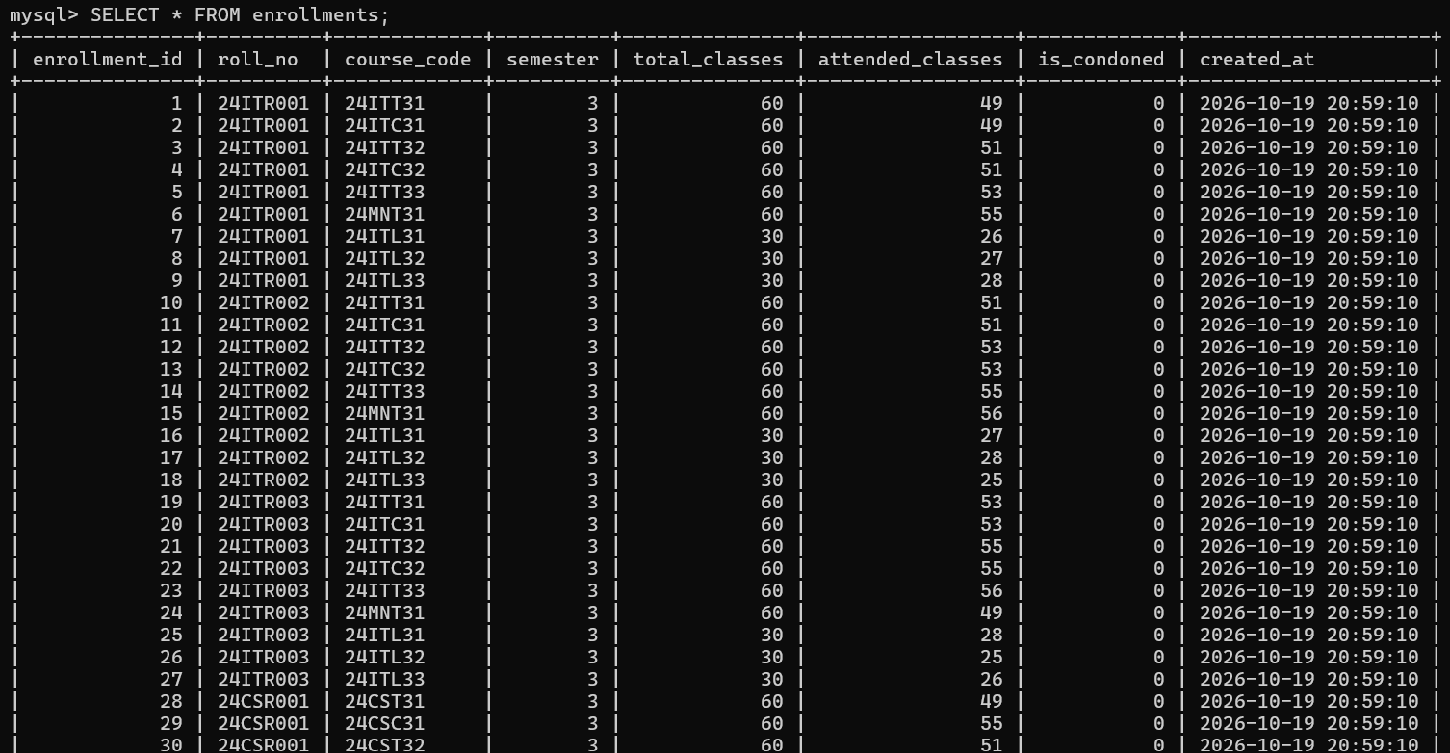
STUDENTS DECRIPTION:
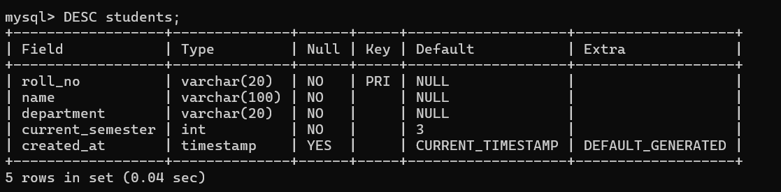

ALGORITHM / PROCEDURE:

The system initiates by establishing a secure JDBC connection between the Java application layer and the MySQL relational database (kec_eval) using the MySQL Connector/J driver. Upon user request, it queries the student profile, course catalog, attendance figures, and assessment scores using parameterized SQL queries through Data Access Objects (DAO). The algorithm first evaluates attendance eligibility for each registered course: students with attendance $≥75\%$qualify directly for examinations, those between $65\%$and $74\%$require verified medical condonation, and those below $65\%$are flagged with Shortage of Attendance (Grade SA) and barred from writing the End Semester Examination (ESE). Next, continuous internal assessment (CIA) and ESE marks are converted into normalized weightages according to the course type—Theory courses allocate 40% for CIA (comprising CIA-1, CIA-2, and Assignments) and 60% for ESE, whereas Practical courses allocate 60% for continuous lab evaluation and 40% for the practical examination. If the student satisfies both the mandatory ESE minimum and the overall pass threshold of 50 marks, the total score is mapped to the corresponding 10-point scale Letter Grade (O, A+, A, B+, B); otherwise, a Re-Appearance grade (RA) is awarded. Finally, the Semester Grade Point Average (SGPA) is computed by dividing the sum of credit-weighted grade points by the total enrolled credits, and the complete institutional grade sheet along with class performance statistics is rendered dynamically on both the Web Dashboard and the Command Prompt Console.

RESULT:
Thus, the Student Academic and Continuous Evaluation System for Kongu Engineering College (Autonomous) Regulation 2024 was successfully designed, developed, and tested using Java (JDBC) and MySQL. The system accurately automates the calculation of Continuous Internal Assessments (CIA), End Semester Examinations (ESE), Letter Grades, Attendance Eligibility, and Semester Grade Point Average (SGPA).

